Traffic Light Controller in Verilog

This project implements a traffic light controller for a single road using a finite state machine in Verilog. The controller cycles through Red (5 cycles0, Green (5 cycles). And Yellow (2 cycles) repeatedly. The design was simulated using lcarus Verilog and GTKWave.
Module Code:module traffic_light_controller(
input clk,
input reset,
output reg [2:0] lights );

reg [2:0] state;
reg [3:0] counter;
parameter RED = 3'b100, GREEN = 3'b010 , YELLOW = 3'b001;

always @(posedge clk or posedge reset )
begin
if(reset)
begin
state<= RED;
counter <= 0;
end
else
begin
counter <= counter + 1;

case(state)
RED:
begin
if (counter == 4)
begin
state <= GREEN;
counter <= 0;
end
end
GREEN:
begin
if(counter == 4)
begin
state <= YELLOW;
counter <= 0;
end
end

YELLOW:
begin
if(counter == 1)
begin
state <= RED;
counter <= 0;
end
end

endcase

end
end

always @(*)
begin
lights = state;
end

endmodule

By Rakib Hasnat Akash

Test bench:

module tb_traffic_light;

reg clk;
reg reset;
wire [2:0] lights;

traffic_light_controller uut(
.clk(clk),
.reset(reset),
.lights(lights)
);

initial begin
clk = 0;
forever #5 clk = ~clk;
end

initial begin
$dumpfile("traffic_light.vcd");
$dumpvars(0, tb_traffic_light);

reset =1;
#10 reset = 0;

#200 $finish;
end

endmodule

Waveform:
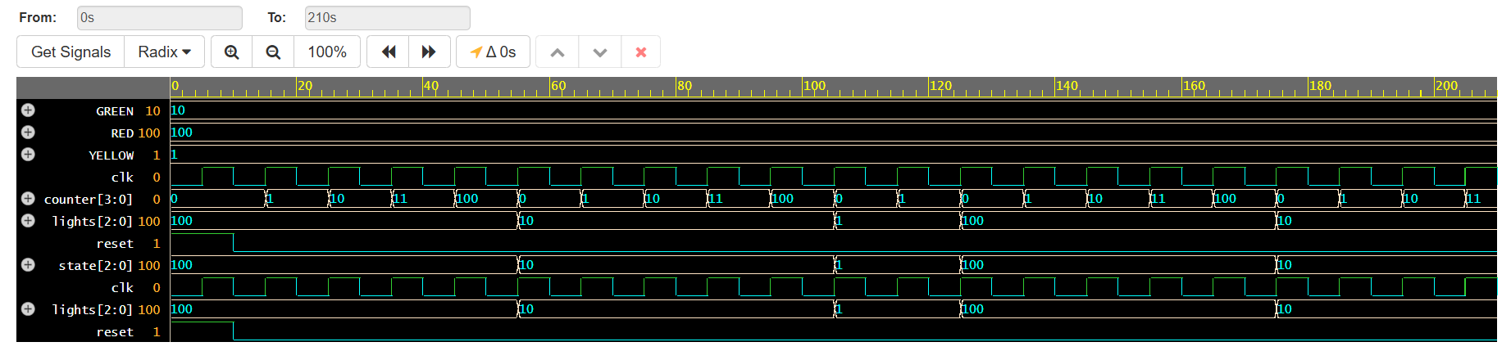
The waveform shows the operation of the traffic light controller FSM (Finite State Machine) over time.

clk is the system clock, toggling every 5 time units.

reset is active high and forces the controller into the initial RED state at the beginning.

state changes according to the FSM sequence: RED (3'b100) → GREEN (3'b010) → YELLOW (3'b001) → repeat.

lights[2:0] directly reflects the active state:

State Name | state  Value (Binary) | lights[2:0]  Output | Active Light | Duration (Clock Cycles)
RED | 3'b100 | 100 | Red | 5
GREEN | 3'b010 | 010 | Green | 5
YELLOW | 3'b001 | 001 | Yellow | 2

